Ishaaq Razack, Savishwa Gaur

Professor Mazidi

CS 4395.001

13 November 2022

Chatbot Project

**System Description:**

This chatbot agent was created to have basic conversations with a user about the popular Japanese anime/manga series Demon Slayer. It was built in Dialogflow, where the developer has to specify each intent, training phrase, and context for the agent. Let’s go over how each of them are specified.

Each intent for the chatbot is basically a possible intention of a customer’s message. Dialogflow agents come with two basic intents: welcome and fallback. Welcome is the intent that is chosen if the user says any kind of greeting to the chatbot, and fallback is the intent that is chosen if the agent cannot understand what the user’s intention is. In addition, we imported the “bye” intent from a pre-built chatbot. Then, we also created three other intents specific to this chatbot: asked_fav_char, asked_fav_fight, and asked_fav_moment. As the names might suggest, these intents are chosen if the agent is asked about its favorite character, fight, or moment from the Demon Slayer series. Finally, we created variations of each of these intents (eg, a variation where the bot already knows the user’s name, or where the bot tries to expand on the user’s dialogue by giving a follow-up question).

The training phrases are what help trigger each intent. Basically, each intent is assigned some training phrases, which are phrases that teach the chatbot agent what should and should not trigger the intent. For example, the “welcome” intent has “hello,” “hi,” and “good morning” as training phrases. Through these phrases, the agent learns what kinds of phrases indicate that the user intends to greet the chatbot. Phrases such as “hi there” and “good afternoon” would also be able to trigger the welcome intent because of this. A full collection of the training phrases can be found in the appendix for the knowledge base.

Another aspect of the chatbot system that helps give it a human-like conversational nature is contextualization. Certain intents, once triggered, create a context, which tells the agent what to expect next in a conversation (ie, what intent will most likely be triggered next). Contexts can also be of different duration length; a context that helps remember a user’s name would have a much longer duration than a context that asks the user a follow-up question. For example, if the user told the chatbot about their favorite character, the chatbot might follow up by asking “what do you like about them?” and create a context that expects the user to mention some feature about that character. However, contexts are not absolute either; if the user simply told the chatbot “goodbye” even when a context was active, the agent would understand that the user intends to end the conversation.

**Dialog Tree:**

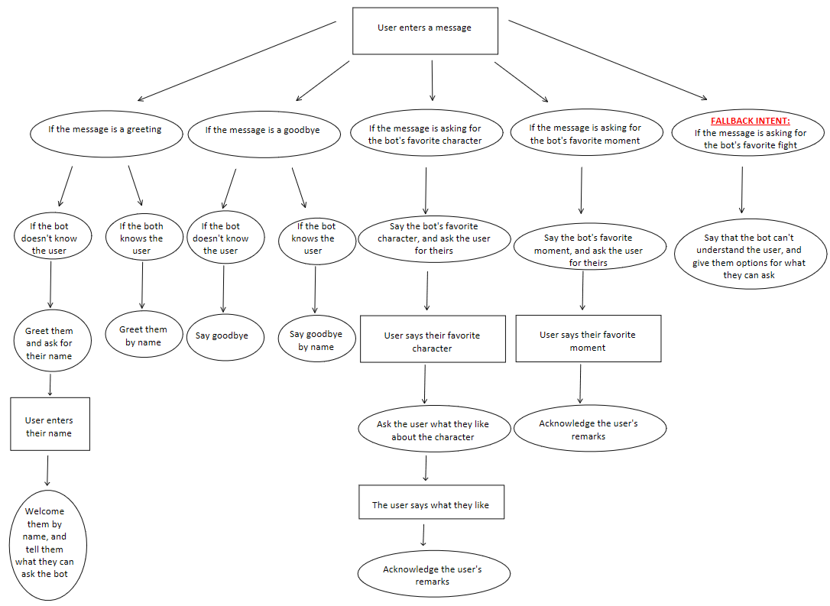

**NOTE:

* If the bot cannot understand the user’s input at any stage, the fallback intent will be triggered.
* At the end of each dialog chain, the dialog flow returns to the top of the tree.

**Sample Dialog Interactions:**

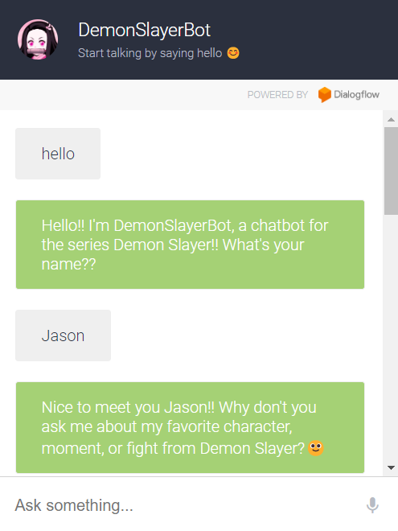

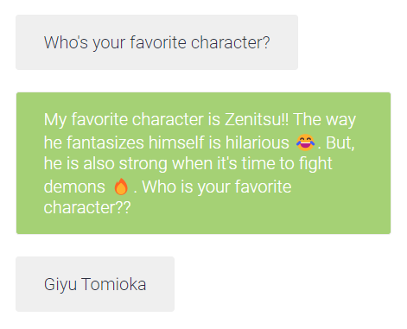

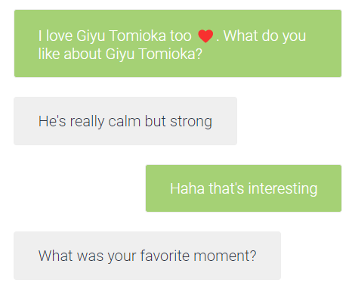

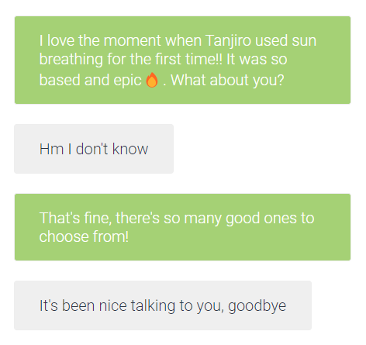

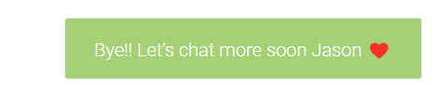

**Appendix for the Knowledge Base**

A full appendix of intents, training phrases, and contexts are attached as a zip file. Each JSON file in the zip folder represents a single intent, and inside you will find the rest of the information.

Also, note that the chatbot’s actual knowledge base may change over time due to testing. Therefore, the chatbot you interact with may have a more sophisticated knowledge base than the one submitted with this report.

**Appendix for Sample User Models Created**

The only user information that is required to be stored for the purposes of this chatbot is the user’s name. Therefore, no complex models were created.

**Evaluations of the Chatbot and Analysis of Its Strengths and Weaknesses.**

Strengths:

* Can use contexts to create longer conversations with the user.
* Fast response times.
* Can use the user’s responses in future dialogue.

Weaknesses:

* Small amount of training phrases for the chatbot agent to learn from.
* Can only understand input that fall in the major intents.
* Can’t understand when the user says something outside of the current active context.